Project Design Phase-II
Data Flow Diagram & User Stories
Date | 03 October 2026
Team ID | SWTID-2026-7282
Project Name | Implement Client Script & UI Policy (Incident)
Maximum Marks | 4 Marks
Data Flow Diagrams:
A Data Flow Diagram (DFD) is a traditional visual representation of the information flows within a system. A neat and clear DFD can depict the right amount of the system requirement graphically. It shows how data enters and leaves the system, what changes the information, and where data is stored.
Example: (Simplified)
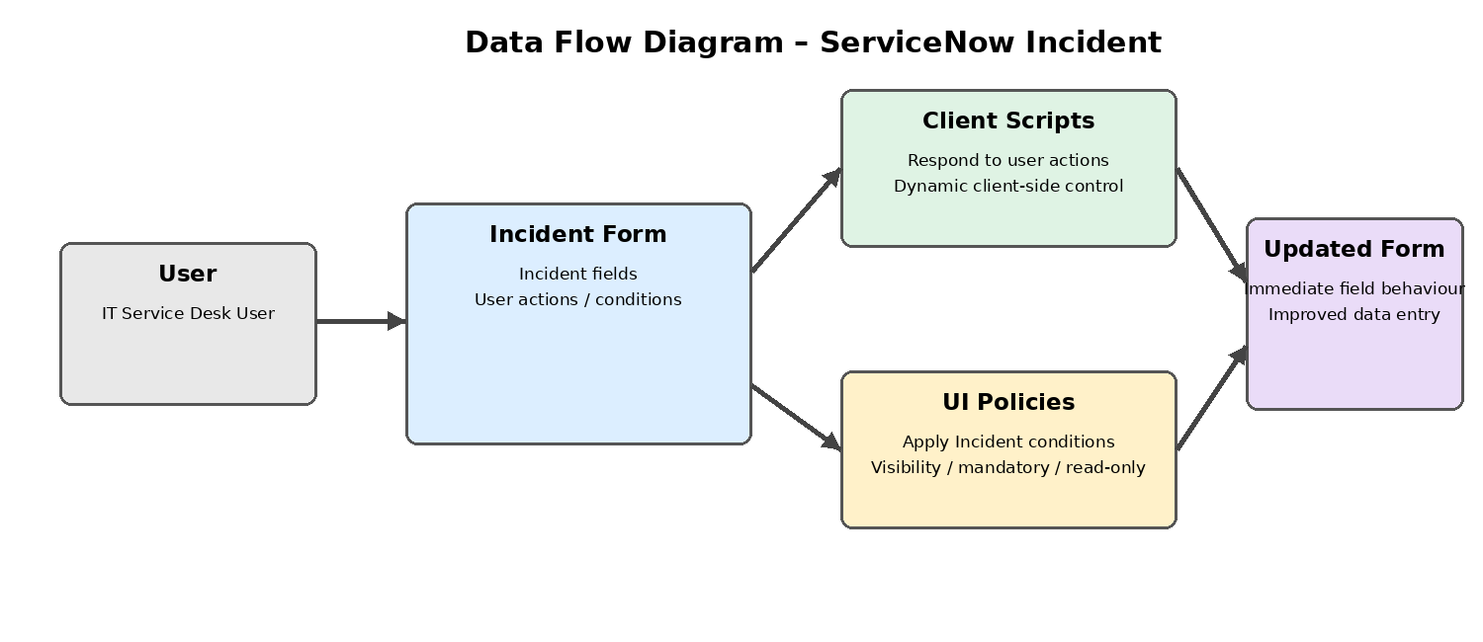

User Stories
Use the below template to list all the user stories for the product.
User Type | Functional Requirement (Epic) | User Story Number | User Story / Task | Acceptance criteria | Priority | Release
IT Service Desk User | Incident Form Dynamic Behaviour | USN-1 | As a user, I can see Incident form fields change dynamically based on my actions. | Relevant fields respond immediately without submitting the form. | High | Sprint-1
IT Service Desk User | Field Behaviour Control | USN-2 | As a user, I can have fields shown or hidden according to Incident conditions. | Only appropriate fields are displayed for the current condition. | High | Sprint-1
IT Service Desk User | Mandatory Field Control | USN-3 | As a user, I can be guided to provide required Incident information when a condition makes a field mandatory. | The required field is clearly enforced before the Incident is completed. | High | Sprint-1
IT Service Desk User | Read-only Field Control | USN-4 | As a user, I can have selected Incident fields become read-only when configured conditions apply. | The configured field cannot be edited while the condition is active. | Medium | Sprint-1
IT Service Desk User | Data Entry Guidance | USN-5 | As a user, I can receive a clearer Incident form experience that reduces incorrect data entry. | Dynamic field behaviour helps the user enter appropriate information. | High | Sprint-2
IT Service Desk User | Immediate Form Response | USN-6 | As a user, I can see the configured field behaviour immediately after a relevant action. | The form responds on the client side without requiring form submission. | High | Sprint-2
Source basis: Adapted from the uploaded Data Flow Diagram & User Stories template. The template's DFD explanation and user-story column structure are preserved, while the sample registration/login stories are replaced with stories supported by the ServiceNow Incident project description.

